Create Database: -

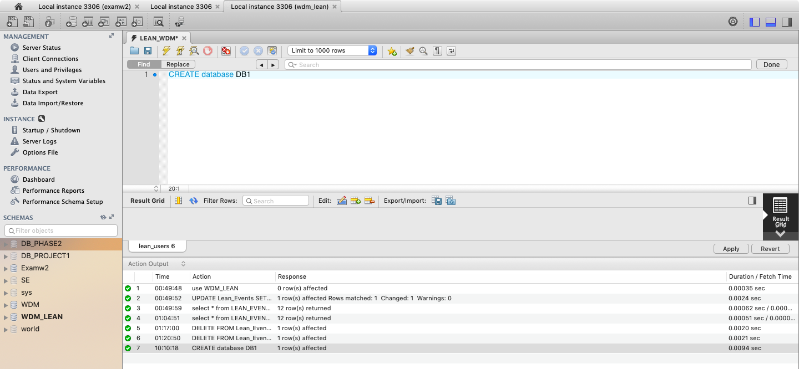

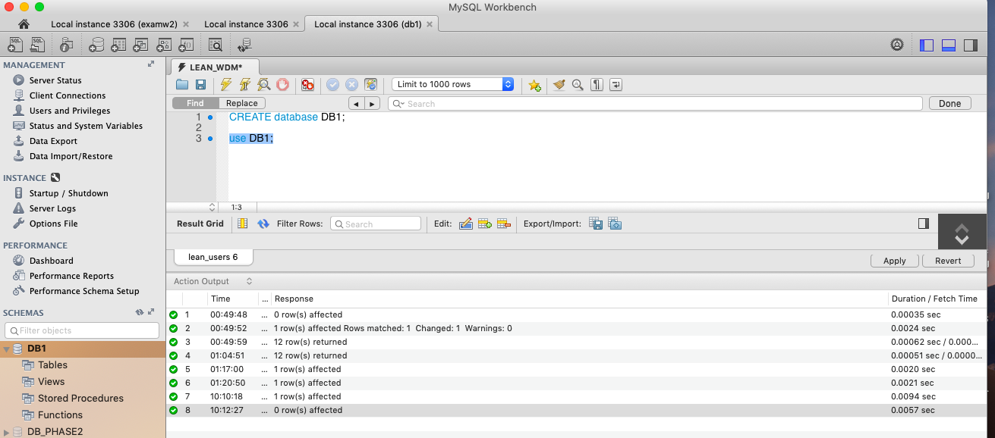

1.Create table Team

CREATE TABLE TEAM (

TeamID varchar(25) NOT NULL,

Team varchar(15) ,

Continent varchar(15),

League varchar(15) ,

Population bigint ,

PRIMARY KEY (TeamID),

UNIQUE KEY (Team)

) ;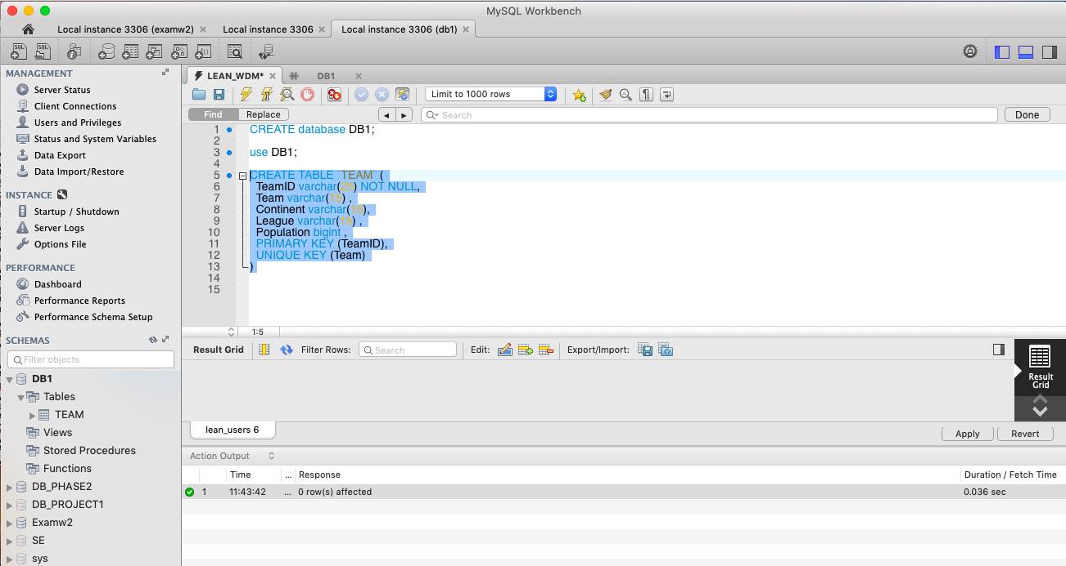

32 records inserted

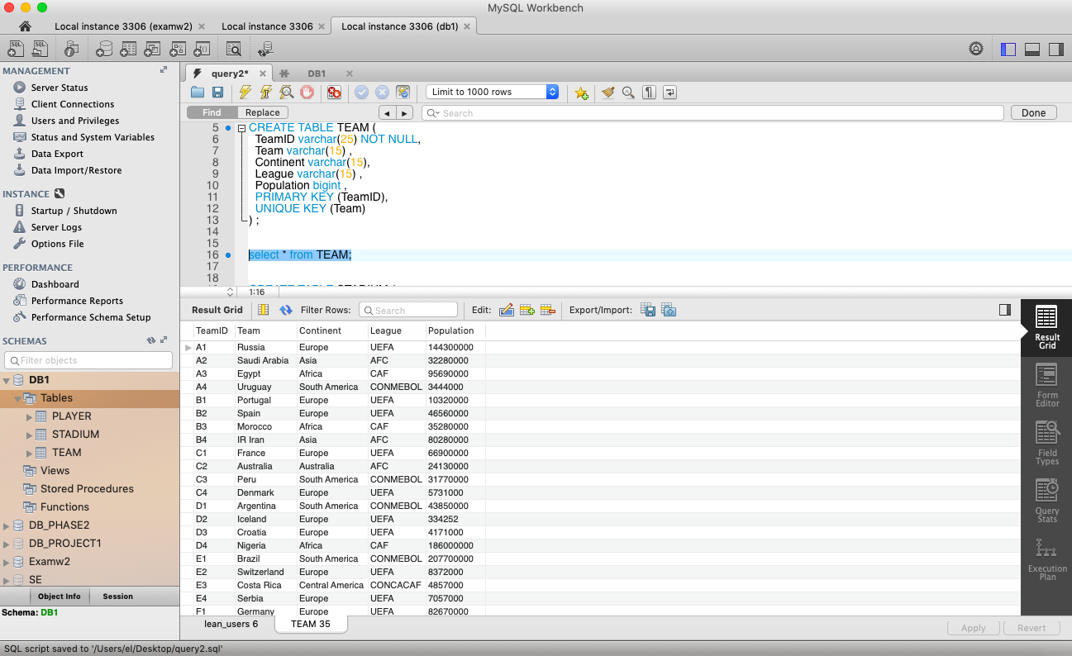

2.Create table STADIUM

CREATE TABLE STADIUM (

SID varchar(25) NOT NULL,

SName varchar(255) ,

SCity varchar(255) ,

SCapacity int,

PRIMARY KEY (SID),

UNIQUE KEY (SName)

) ;

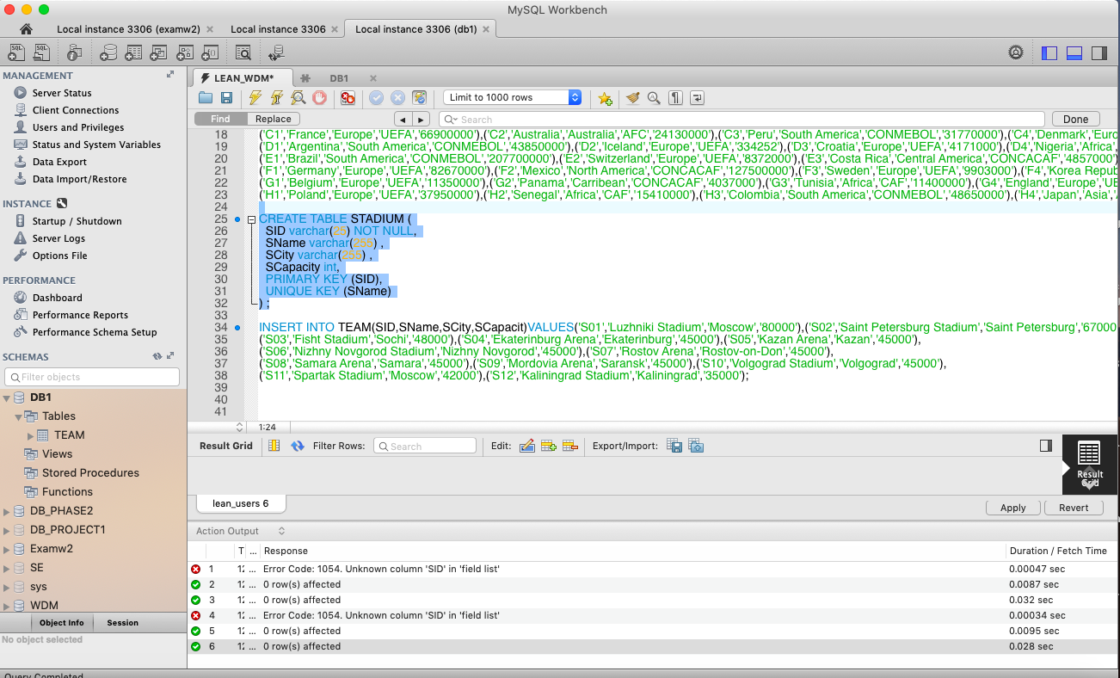

Insert values

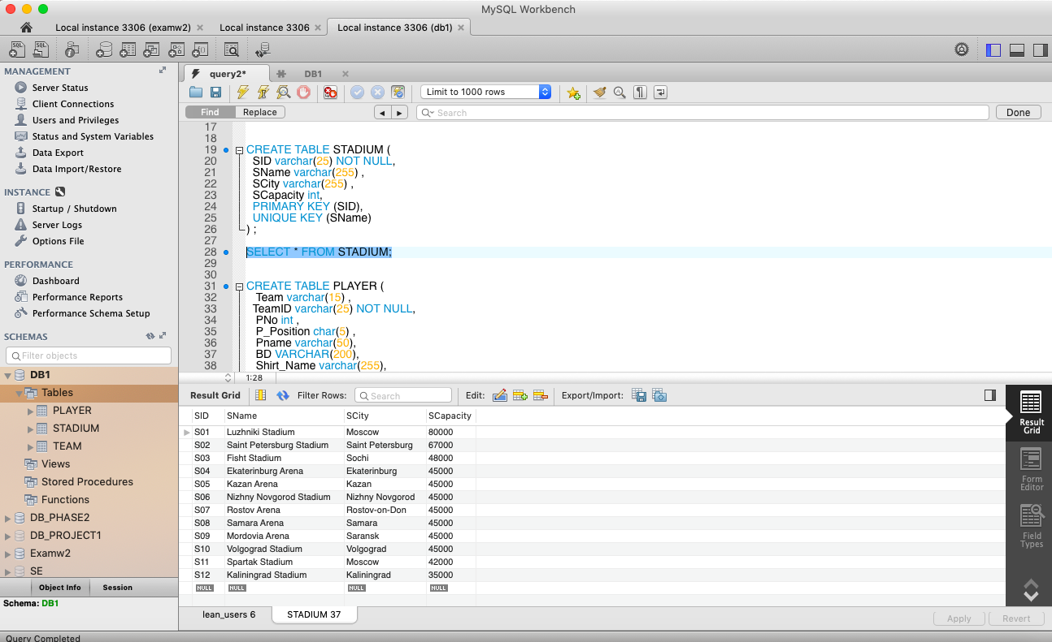

3.Create table PLAYER

CREATE TABLE `PLAYER` (

Team varchar(15) NOT NULL,

TeamID varchar(25) NOT NULL,

PNo int NOT NULL,

P_Position char(5) ,

Pname varchar(50) ,

BD varchar(200) ,

Shirt_Name varchar(255),

Club varchar(255) ,

Height int,

Weight int,

PRIMARY KEY (TeamID,PNo),

CONSTRAINT `player2` FOREIGN KEY (TeamID) REFERENCES TEAM (TeamID)

) ;



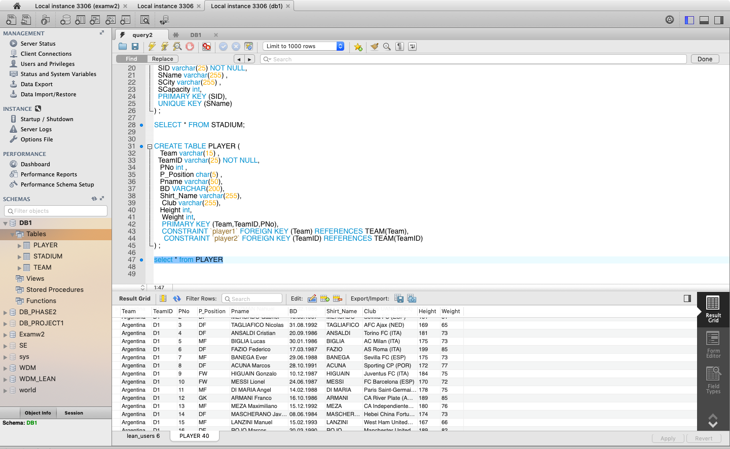

4.Create table GAME

CREATE TABLE GAME (

GameID VARCHAR(25) NOT NULL,

Match_Type CHAR(10),

Match_date varchar(20),

SID varchar(25) ,

TeamID_1 varchar(25) NOT NULL ,

TeamID_2 varchar(25) NOT NULL,

Team1_Score INT,

Team2_Score INT,

PRIMARY KEY (GameID),

CONSTRAINT `game_1` FOREIGN KEY (SID) REFERENCES STADIUM (SID),

CONSTRAINT `game_2` FOREIGN KEY (TeamID_1) REFERENCES TEAM (TeamID),

CONSTRAINT `game_3` FOREIGN KEY (TeamID_2) REFERENCES TEAM (TeamID)

) ;

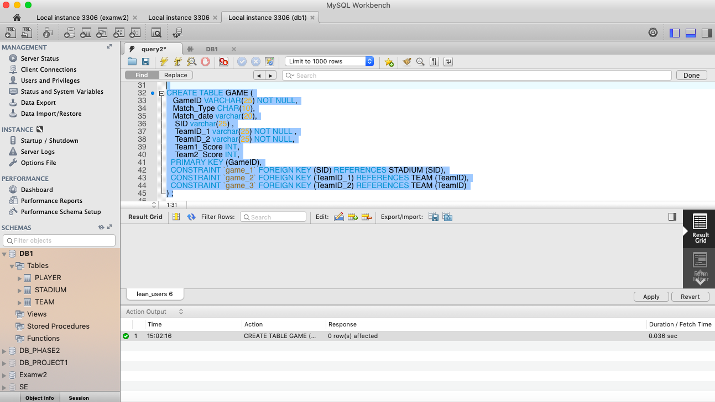

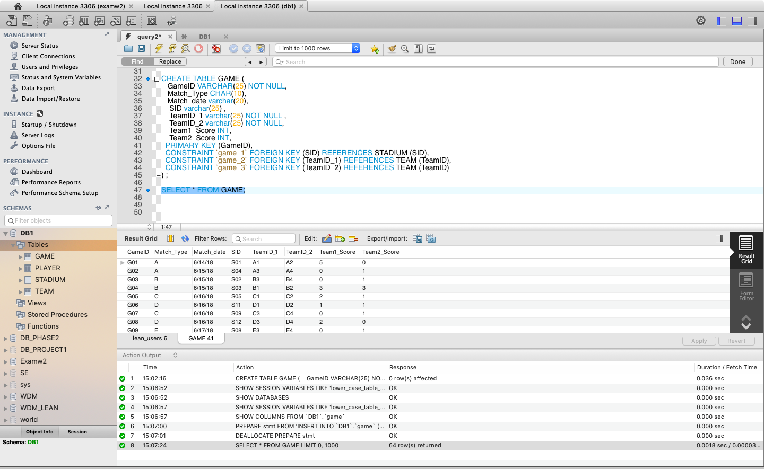

5.Create table STARTING_LINEUP

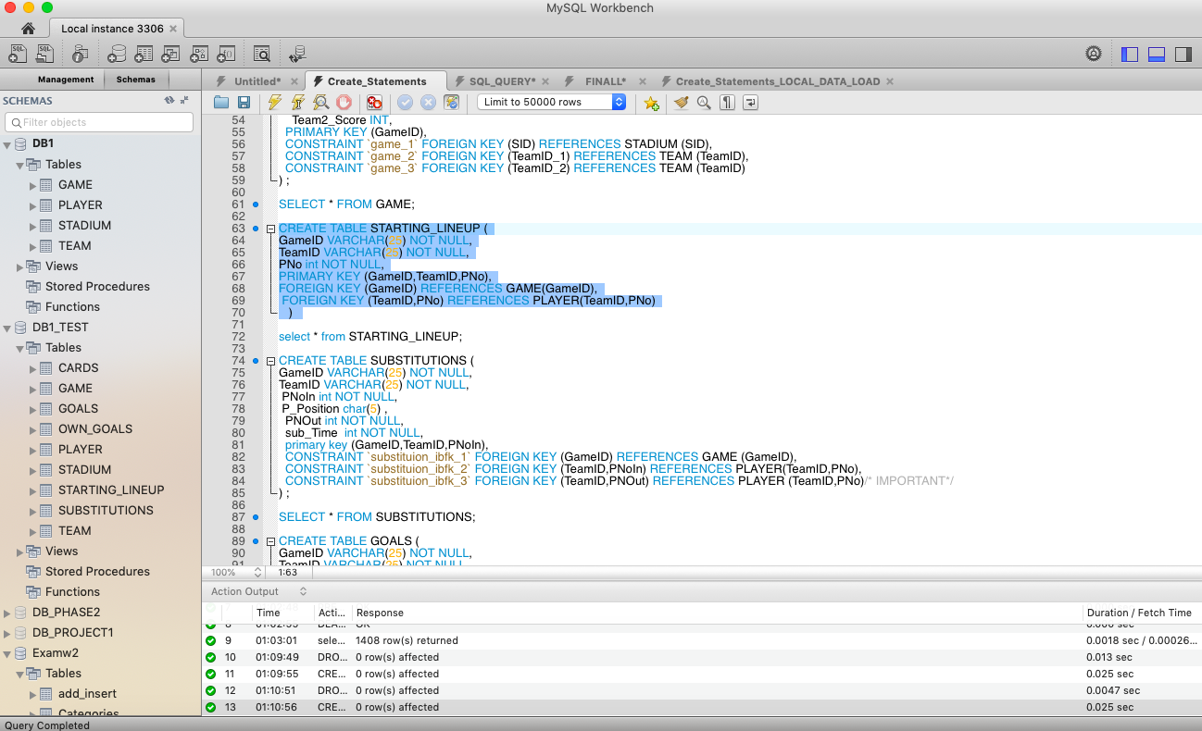

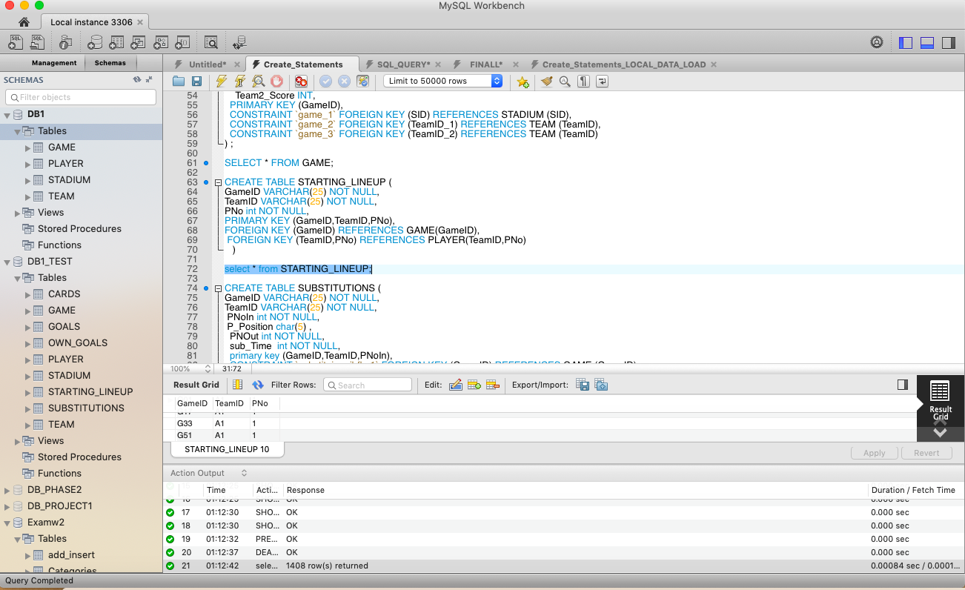

6.Create table SUBSTITUTIONS

CREATE TABLE SUBSTITUTIONS (

GameID VARCHAR(25) NOT NULL,

TeamID VARCHAR(25) NOT NULL,

PNoIn int NOT NULL,

P_Position char(5) ,

PNOut int NOT NULL,

sub_Time int NOT NULL,

primary key (GameID,TeamID,PNoIn),

CONSTRAINT `substituion_ibfk_1` FOREIGN KEY (GameID) REFERENCES GAME (GameID),

CONSTRAINT `substituion_ibfk_2` FOREIGN KEY (TeamID,PNoIn) REFERENCES PLAYER(TeamID,PNo),

CONSTRAINT `substituion_ibfk_3` FOREIGN KEY (TeamID,PNOut) REFERENCES PLAYER (TeamID,PNo)/* IMPORTANT*/

) ;

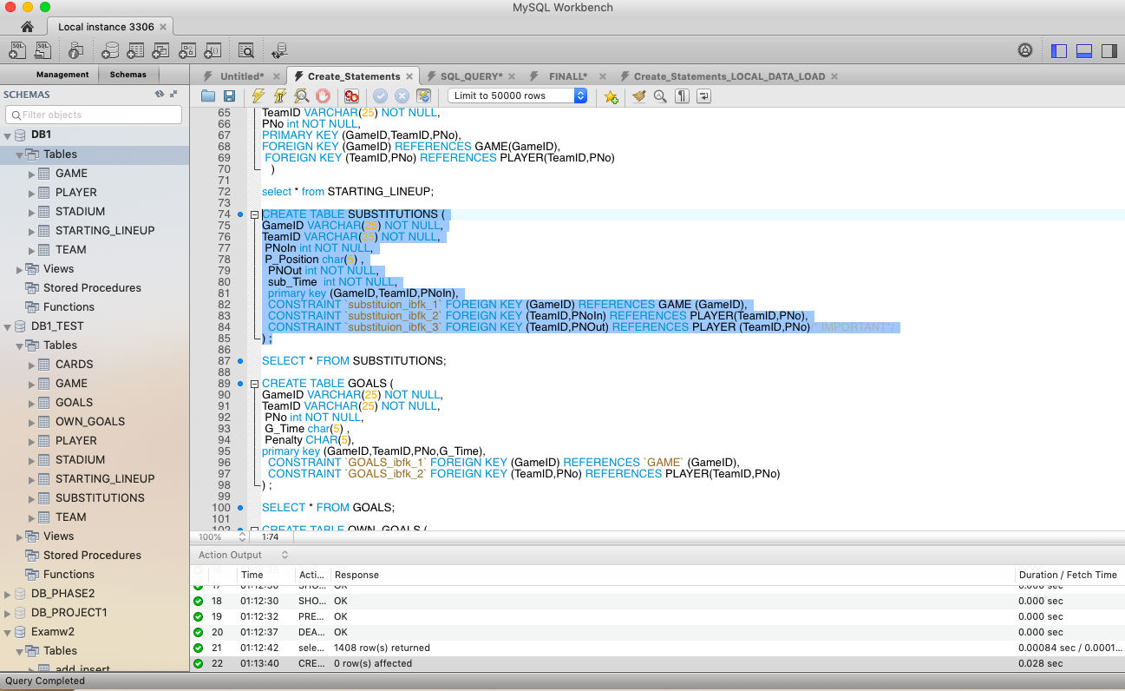

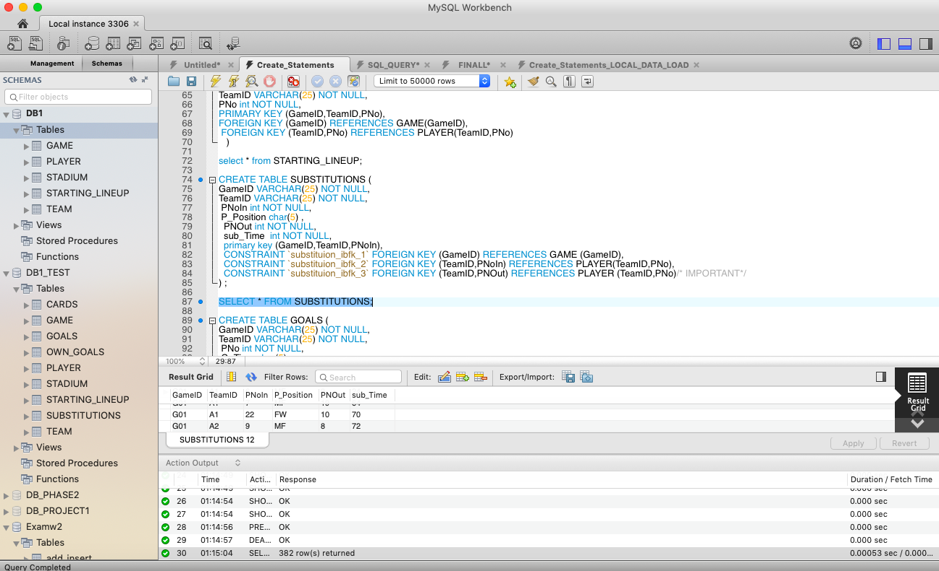

7.Create table GOALS

CREATE TABLE GOALS (

GameID VARCHAR(25) NOT NULL,

TeamID VARCHAR(25) NOT NULL,

PNo int NOT NULL,

G_Time char(5) ,

Penalty CHAR(5),

primary key (GameID,TeamID,PNo,G_Time),

CONSTRAINT `GOALS_ibfk_1` FOREIGN KEY (GameID) REFERENCES `GAME` (GameID),

CONSTRAINT `GOALS_ibfk_2` FOREIGN KEY (TeamID,PNo) REFERENCES PLAYER(TeamID,PNo)

) ;

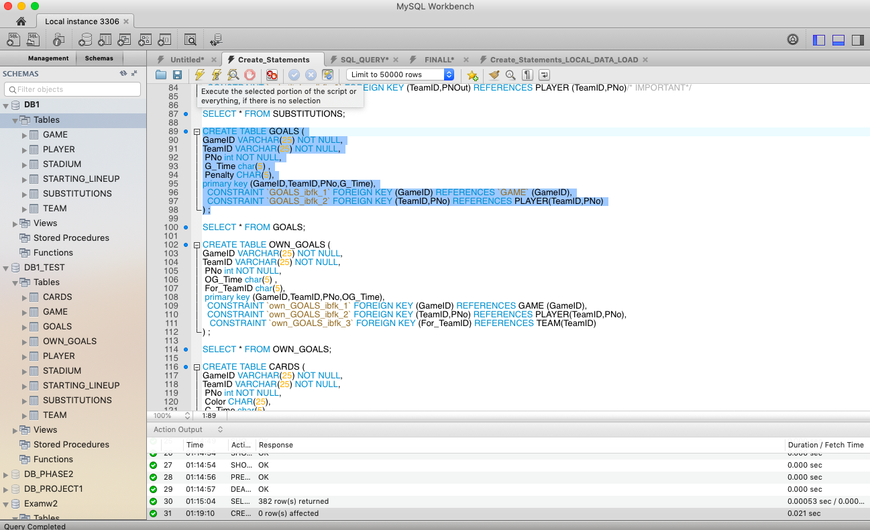

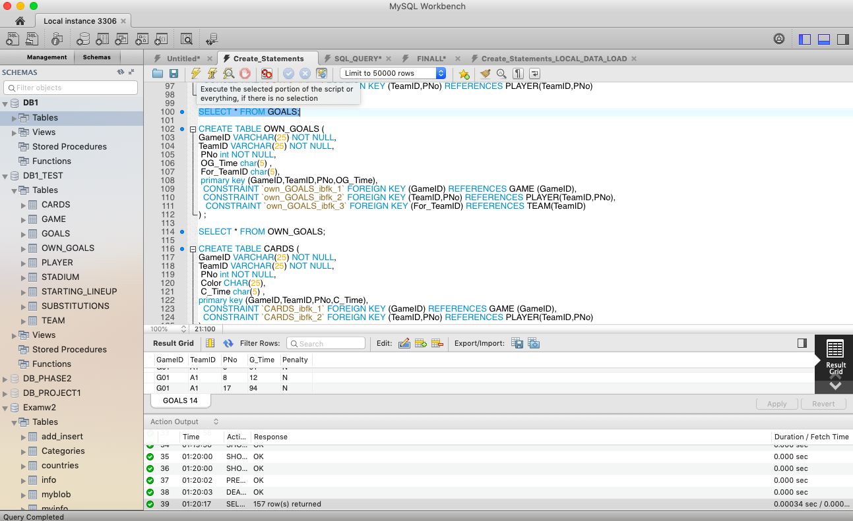

8.Create table OWN_GOALS

CREATE TABLE OWN_GOALS (

GameID VARCHAR(25) NOT NULL,

TeamID VARCHAR(25) NOT NULL,

PNo int NOT NULL,

OG_Time char(5) ,

For_TeamID char(5),

primary key (GameID,TeamID,PNo,OG_Time),

CONSTRAINT `own_GOALS_ibfk_1` FOREIGN KEY (GameID) REFERENCES GAME (GameID),

CONSTRAINT `own_GOALS_ibfk_2` FOREIGN KEY (TeamID,PNo) REFERENCES PLAYER(TeamID,PNo),

CONSTRAINT `own_GOALS_ibfk_3` FOREIGN KEY (For_TeamID) REFERENCES TEAM(TeamID)

) ;

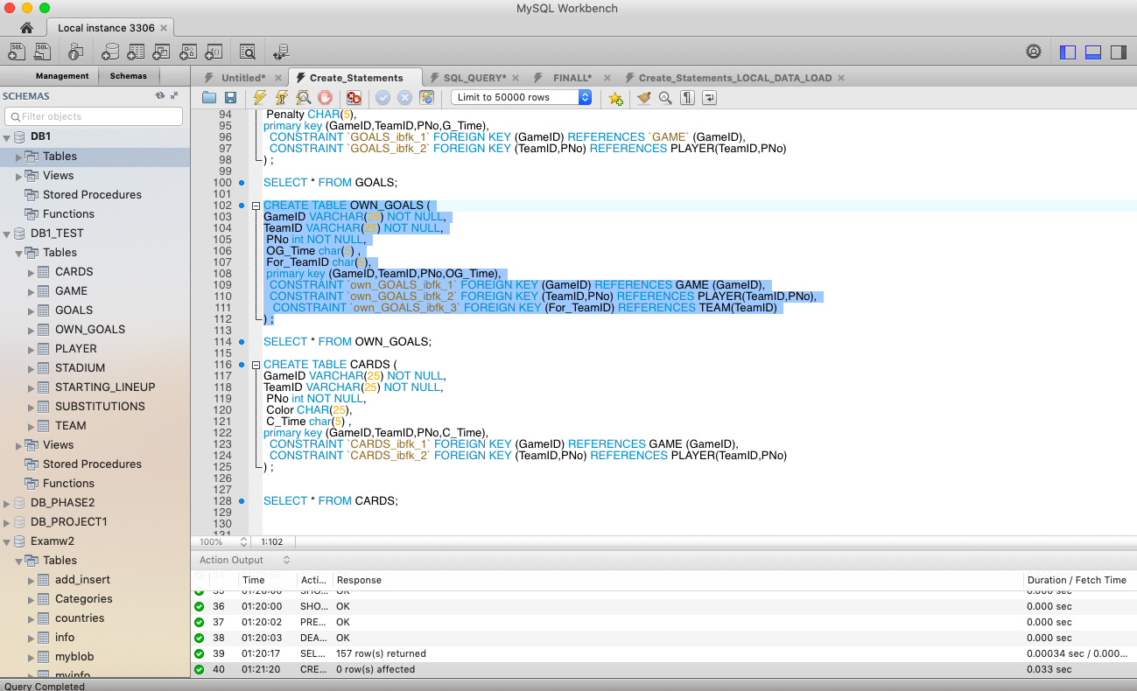

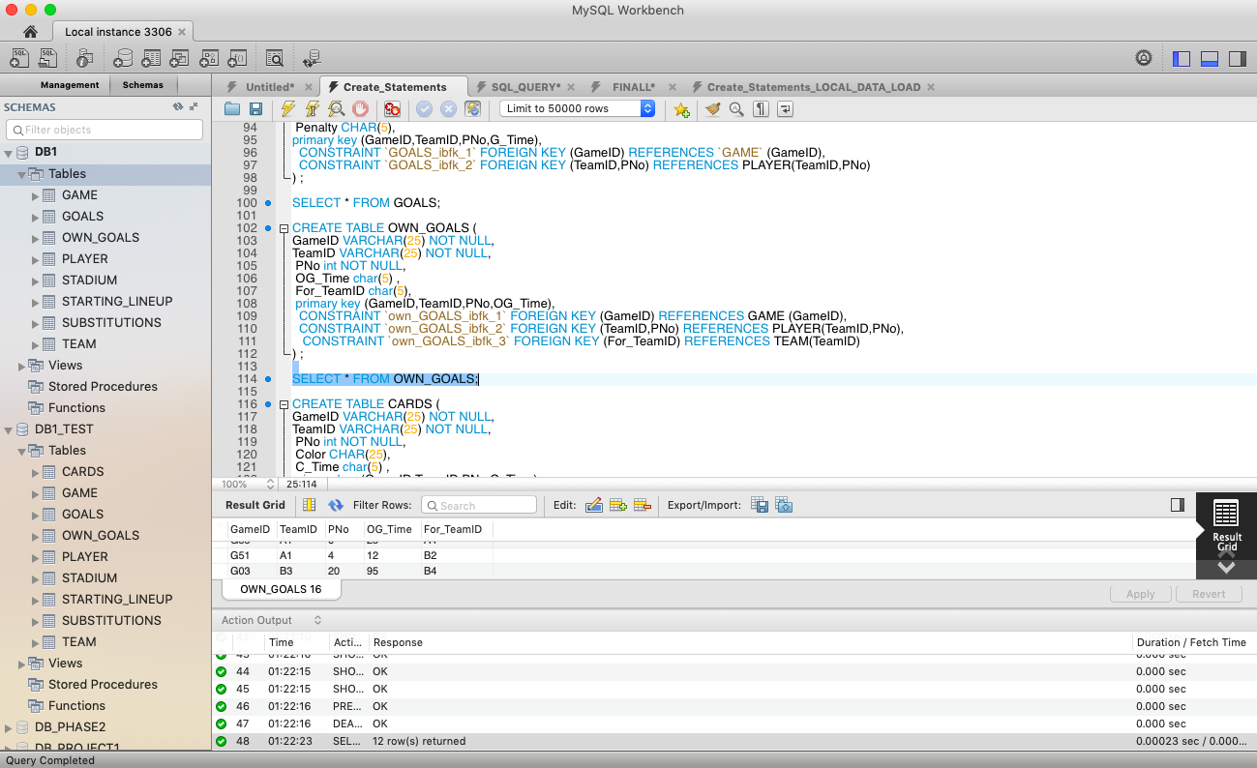

9.Create table CARDS

CREATE TABLE CARDS (

GameID VARCHAR(25) NOT NULL,

TeamID VARCHAR(25) NOT NULL,

PNo int NOT NULL,

Color CHAR(25),

C_Time char(5) ,

primary key (GameID,TeamID,PNo,C_Time),

CONSTRAINT `CARDS_ibfk_1` FOREIGN KEY (GameID) REFERENCES GAME (GameID),

CONSTRAINT `CARDS_ibfk_2` FOREIGN KEY (TeamID,PNo) REFERENCES PLAYER(TeamID,PNo)

) ;

